**Labor Day**

**Sept. 3 & 4, 2018**

**NO SCHOOL**

**Grandparents Luncheon**

**Friday, Sept. 7, 2018**

**More Information to Come!**

**Coffee with the Counselor**

**Tuesday, Sept. 18, 2018 from 8-9am**

**in GMS Media Center**

# imgresDates to Remember

**PLEASE JOIN MY REMIND!!**

**REMIND helps the counselor communicate with parents in regards to important events and information occurring at the school**

**Text code: @e6fcfe**

**to**

**Number 81010**

* Please review my REMIND info below and sign up to receive information about school events!
* If interested in the Belk’s Charity Fundraiser please contact the school. Tickets are $5.00 and money will help raise funds for our school.
* This year we will be using myON to encourage reading. Students should be reading at home as well. Ask your child about myON.
* Please help us welcome our new **Asst. Principal Mr. Antonio Owens** to Greenville Middle School!!

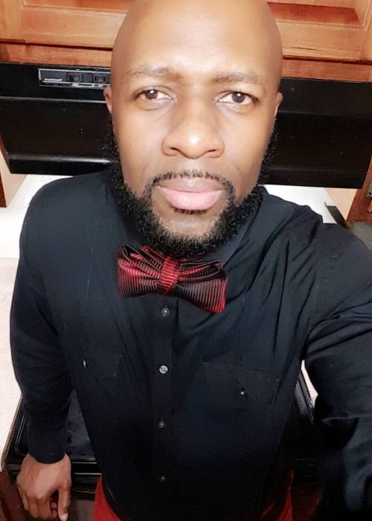

**Please visit our website for all things GMS!**

**Website:** <http://gms.mcssga.org>

**Facebook:** [www.facebook.com/GMHSPats/](http://www.facebook.com/GMHSPats/)

**Twitter:** @GMHSpats

Mrs. Sales’ Announcements

Welcome Back!!!

Counselor’s corner

GREENVILLE

MIDDLE

SCHOOL

August 2018

banner with apples and crayons